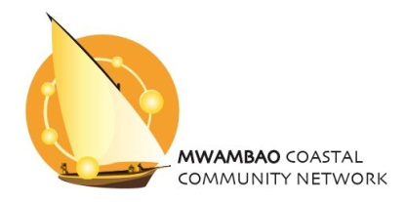

Coral Communities Workshop
Veranda Pointe aux Biches Hotel, Mauritius
10-11 May 2017

Workshop Report

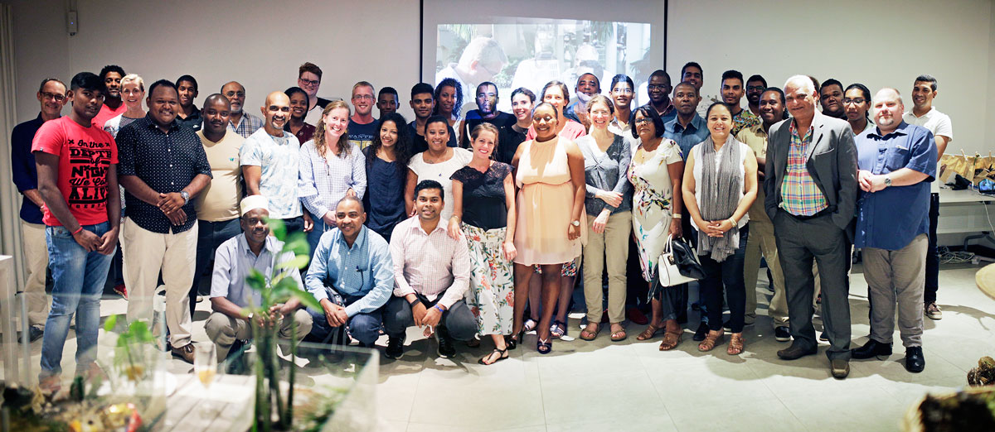

The overall aims of Coral Communities (a Global Challenges Research Fund project) are two-fold: to identify and critically assess the effectiveness and potential of management and development strategies to build resilience of coral reefs and dependent communities in the Western Indian Ocean (WIO), and to understand to what extent ecosystem services language and approaches facilitate development and implementation of such strategies.

This WIO workshop had a number of objectives related to the overarching research aim:
- Prioritise resilience strategies of interest to the WIO, collate evidence of success and best-practice in their implementation, and identify opportunities to improve resilience-building strategies in the future.
- Trial a visual method of community engagement involving image exchange, participatory mapping, creation of mini coastscapes and participatory video to assess and potentially enhance resilience strategies.
- Draw together a diverse group of stakeholders from across the WIO who may be interested in future collaborations around resilient coral reefs and coastal communities.

What follows is a summary of outputs from the two days of discussions.

1. Building resilience in practice
A number of themes emerged from the short introductory presentations given by the regional participants and Reef Conservation about their current work:
- Marine Protected Areas (MPAs), both voluntary and statutory, and octopus fishery closures were widely used management strategies.
- Long-term monitoring activities, with many organisations sharing their data within local and international networks.
- Education activities with children and the wider community included the use of traditional and social media as well as special events.
- Capacity building activities, training local people in research and monitoring skills as well as providing teacher training, certified eco-guide courses for the tourism industry and creating “green collar” jobs in the environmental sector.
- Economic development projects more widely included aquaculture (seaweed, sea cucumbers) and opportunities to add value to traditional produce (such as through drying fish), as well as seeking more widely to understand the blue economy and its contribution to sustainable development goals.
- Mangrove and wetland rehabilitation programmes were also underway, including trialling carbon credit options.
- Coral reef restoration projects comprised growing “super corals” with bleaching resilience and building artificial reefs.
- Other tools to support sustainable outcomes included installing permanent mooring buoys and snorkelling trails, and developing eco-certification schemes.
- Community involvement was a cross-cutting theme and included working with fishermen in monitoring, volunteer support for mangrove rehabilitation and beach cleaning, and community involvement in enforcing MPA restrictions, particularly with regard to poaching.
- Establishing connections with the private sector and the development of corporate social responsibility (CSR) schemes.
- Ensure community voice in environmental policy, using participative approaches (including resource mapping), and local laws and customs (such as the Dina in Madagascar).
- Understanding and communicating the community impact of research was also an important part of the participants’ work.

2. Similarities and differences in resilience strategies
The role of the community was emphasised as essential in effective resilience strategies. Strategies were primarily place-based, and so required understanding of economic development, literacy levels, culture and community rights (including local laws and management agreements). Developing appropriate tools was also important, as was using the correct language such as engaging business by emphasising the benefits to them rather than focussing solely on the conservation outcomes.

The tourism industry was referred to as a specific sector that had been, and should continue to be, engaged with in developing and implementing resilience strategies, and was described as fundamental in the Seychelles. This sector (ranging from private boat operators to large hotel chains and airlines) had been involved in the design and creation of MPAs, and had provided financial support as well as in-kind contributions of staff time. The value of international knowledge exchange, where tourists take home and share conservation messages, was also highlighted. Challenges in working with the industry were acknowledged, particularly that not all priorities were shared, and that there was a need to increase environmental awareness within the sector. The absence or lack of transparency in benefit-sharing mechanisms (such as the distribution of revenue from tourism taxes) required addressing. Effective engagement with tourism also required defined policies to provide clarity for investors, as well as a balance sheet between eco-tourism and conservation: for every tourism action there must be an appropriate conservation action.

Monitoring is also required to understand the factors contributing to resilience. Research networks, and the use of common techniques, are also beneficial for increasing the volume of comparable information and providing support. Sites with easy access and the use of simple methods will also increase the potential for monitoring, as the resource requirement is lower. Financing remains essential in developing resilience strategies. Sources of funding included grants and donations (encompassing Corporate Social Responsibility), voluntary contributions for community MPAs, and trust funds. In the Seychelles, a Foundation model was also employed, in which a network of organisations and businesses provide funding and resources to support ongoing programmes.

3. What do we understand by resilience?
Resilience
Resilience was discussed mostly in the context of climate change, but described as the ability of communities or ecosystems to bounce back, adapt, resist or recover from any kind of pressures but not necessarily to the same state. It was noted that the word “resilience” was rarely employed in outreach activities even though the concept was fundamental to marine management and development activities, due to it being a technical term and not part of everyday language. Terms such as “sustainability”, “durability”, and “adaptation” were more commonly used, as these were more intuitive and straightforward, and also linked to future generations.

Social resilience
The resilience of communities is dependent on the type and level of the threat, and increasing it requires changes in community structure, mind set and in decisions about the resource. Resilience strategies have different scales, and should include tools such as a vulnerability index which can be applied at the national level, as well as strategies at a community-specific level. Education and knowledge sharing, at all levels, and understanding the multi-cultural ethics and traditions of how we connect to nature are essential in social resilience. The development of resilience strategies requires community involvement, understanding how they can adapt and employing appropriate actions for them, as well as sensitisation, mobilisation and training. Alternative livelihoods are key for increasing the diversity of economic options.

Ecological resilience
The resistance and recovery aspects of ecological resilience are both important, and need to be considered at both the species and site level. Resilience strategies should encompass the whole ecosystem, not just coral. Biodiversity is key, and while climate change was currently a major focus other pressures should not be ignored. Corals can be considered resilient if they have survived despite a history of bleaching events as well as wider degradation and pressures such as fishing. They need the ability to adapt to changing environments, particularly to bleaching and climate change. Participants emphasised the strategy of coral reef restoration that selected for corals resilient to previous El Niño events in the region (1997-1998 and 2015-2016).

Key components for building resilience
- Collaboration between Governments, Academics and NGOs, as well as community engagement is essential for wider resilience strategies.
- Collaboration and learning lesson from across the WIO is crucial and cross country partnership needs to be fostered.
- Examples of local success stories can help the public to understand why the strategies and actions are important, and can be used to support lobbying to have a national impact.
- Funding mechanisms are essential (large funders in particular have a role in scaling up projects), as is the provision of in-kind support where funding is not available.
- Monitoring is required to assess the health of the reefs and identify more resilient corals, to provide data that can focus management efforts.
- Sharing monitoring and research data is also beneficial.

4. Trade-offs between social and ecological resilience
The workshop participants recognised that the separation between ecological and social resilience is artificial, but that there are often tensions and conflicts between social and environmental objectives.
MPAs are one example: they are a key tool for the management of resources and resilience, but are not always supported by the community and their implementation and management can be affected by wider political issues. These political differences can be manifested at a local level where strong opposing party allegiances may affect collaboration between key stakeholders such as village headmen and the leaders of fishermen’s associations. Overcoming this needs expertise in conflict resolution. Stakeholders, such as scientists, managers and communities may also differ in their perspectives on what a resilient and desirable coral reef system looks like. For example, branching Acropora dominates in Mauritius and has shown some resilience to previous El Niño events – while it may bleach easily it recovers quickly. However, the community did not want Acropora to be part of a coral farming project in Mauritius (and ideally would prefer it to be removed from the lagoon entirely), because it does not attract the “right” fish, damages nets and prevents boat passage due to its fast growth.

Other issues in community engagement are that local people are busy. International donors want to provide lots of training, but people do not have the time. Communities have to see the value to themselves of such activities. This lack of time can result from economic development, but also from poverty and the need for subsistence activities.

5. Using visual methods to understand resilience
This session started with a discussion of who already uses visual methods to engage with communities and how they use them. It was followed by three sessions: creating coastscapes with tips on participatory video, how to take a good photograph and image exchange.
All images below by Jason Parsons.

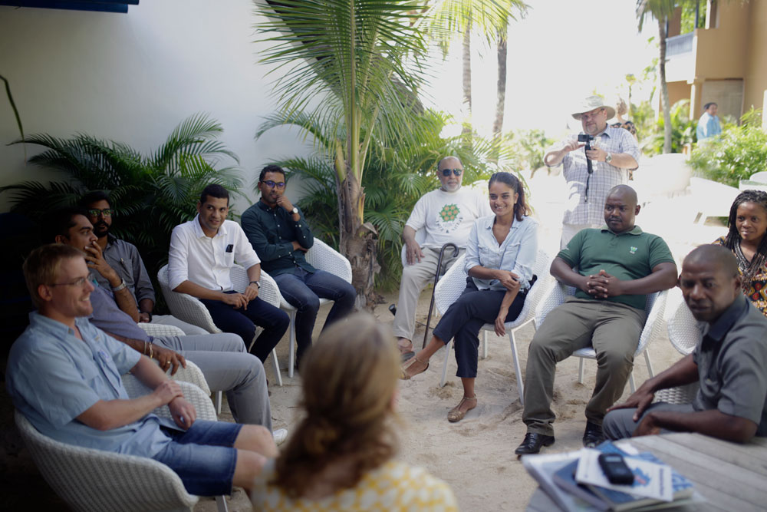

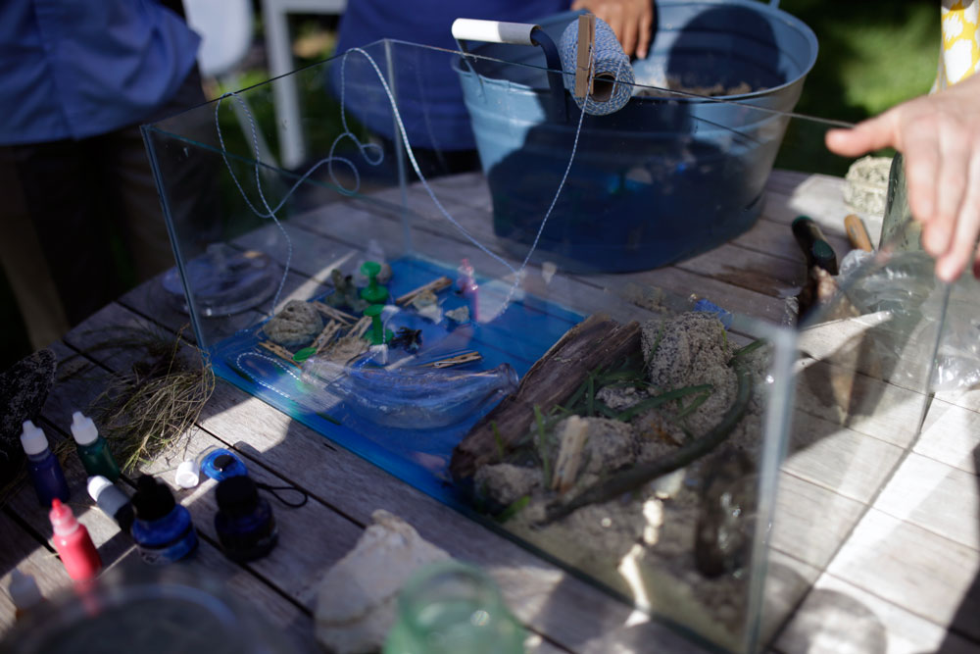
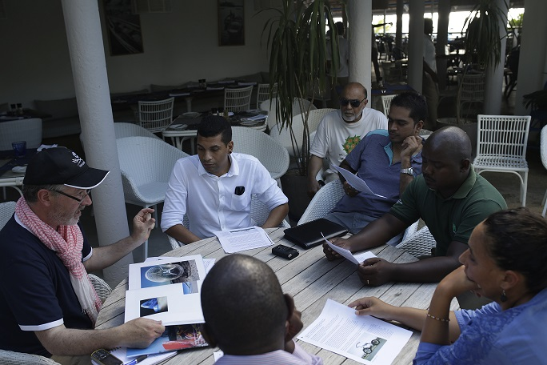

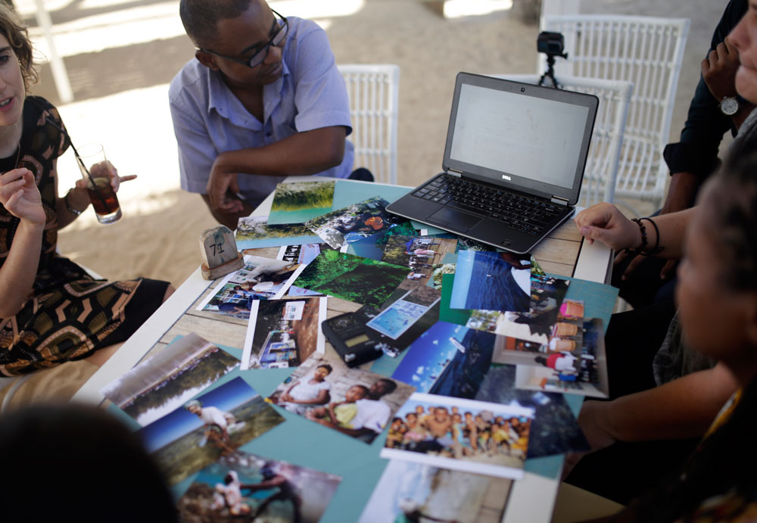

6. Group work focusing on key resilience strategies
The study team produced report cards for 14 resilience strategies identified from the academic literature. These were prioritised by the participants and four were discussed in detail. The table below provides a summary of these discussions. The micro-finance group also discussed Locally Managed Marine Areas (LMMAs). While the output of this discussion is not captured here, it will be in the incorporated into the literature review.

 | Payments for Ecosystem Services | Micro-finance | Alternative Livelihood Strategies (ALS) | Coral reef restoration
Where have they been applied in the WIO? | No working examples in WIO, other than REDD+ project in mangroves in Zanzibar.  There is interest:  - Seychelles considering two schemes (bottled water companies paying Seychelles National Parks Authority for forest management and hotels pay towards marine park management).  - BV (Madagascar) working on a REDD+ project.  - In Mauritius, user fees are charged for marine parks with revenue contributing to marine management. | One example of VICOBA (Village Community Banks) in Tanzania | Strategy is used throughout the WIO.  Eco-tourism and mariculture were considered particularly important alternative livelihoods, especially in low income countries. Women seen as a key target group for the development of alternative livelihoods. Examples of eco-tourism in Comoros and mariculture in Madagascar.  In Mauritius, expectations for those leaving fishing is focused on professional level occupations. | In Mauritius  - Small pilots (from 2010)  - Academic , Government, NGOs, tourism  - Developing large international projects  - Shipwrecks (since 1980)  Other countries were not discussed as all participants were from Mauritius.
How are we or should we monitor the outcomes of PES schemes? | Need to monitor:  - that money does go to ecosystem management, restoration and enhancement.  - to demonstrate benefits  - to ensure enforcement.  - for transparency  Benefits to different communities/stakeholders will need to be monitored in different ways. | Donors provide match funding for VICOBA and are responsible for monitoring the outcomes. Evaluations are rarely published so little is known about the benefits of VICOBA. | Monitoring is needed to ensure:  - community is helped to deliver the good/service and have required training.  - good/service is provided in a quality assured, timely manner.  - the ecosystem is managed, restored, enhanced through alternative livelihood strategies  Also need to monitor who is benefiting.  Need robust and consistent data from community and ecosystem perspective.  NGOS well placed to offer this monitoring. Independent evaluation also needed. | - Monitoring to date has been limited (as expensive, resource intensive, and lack skilled personnel), but data loggers have been deployed at some nurseries and there are diver anecdotes from artificial reefs  - There is a need for more site monitoring before projects begin and generally more ecological and socio-economic monitoring
What has been successful? | Too early to tell as no working examples, but successes generated from payments for use schemes:  - Many direct and indirect benefits.  - Human pressure relieved from sites.  - Shift in jobs from fishing to tourism.  - Enforcement not always successful.  - Money used to improve stakeholder communication. | There is a general sense that such schemes are beneficial but little documented evidence.  Success more likely where:  - Support is provided to help members develop by-laws to guide repayment of loans.  - Training modules are provided to help members start and manage a business or project. | BV model in Madagascar is considered very successful. Focused on seaweed and sea cucumber farming with fishing families. BV works as intermediary between workers and the company buying the product.  In Comoros, fishers seen as key group for eco-tourism development. Key group for alternative livelihood, but also for ensuring community acceptability. | - Ecological: some very local increases in growth, recruitment, biodiversity  - Social: raised awareness of coral ecology, ownership (corals tagged with names, increased tourism at artificial reefs with fishers respecting the sites
Will it be useful/successful in the future? Is it future proof? | - To support success there is a need for ecosystem service valuation and the need to pay for them, otherwise payments become arbitrary.  - There needs to be more research to make relevant for the marine environment.  - Need to fit within existing tax regulatory frameworks.  - Need to understand from perspective of the payer – how will they benefit from things we cannot control?  - Price uncertainty associated with market fluctuations – increase in credits offered leads to falling price for credits – does not make sense from environmental perspective. | Not discussed as few ongoing examples of micro-credit. Many donors have priorities other strategies. | - ALS must meet needs, expectations and skills capacity of the community.  - There must be a real commercial market for the good/service.  - Communities need to feel their effort is real and observe tangible success.  Government must support ALS (hard and soft resources e.g. financial resources and policy, promotion and knowledge exchange). | - Concerns it is not future proof, due to risks from climate change  - Artificial reefs do not fulfil all ecological roles (e.g. not CO₂ sink)  - Improving future success needs careful site and species selection, and more information on other projects success and failure.
Who benefits and how? | - With REDD+ schemes, at least 50% of benefits should go to the communities.  - Benefits should be shared between/among communities.  - If it is transparent, everyone should benefit. | - In principle, accessible to everyone in a village.  - Often women are more involved due to their experiences with Merry-go-rounds.  - Schemes are failing to appropriately target fishers using destructive gears. | Potential to benefit many, but ALS need to be targeted to a particular need. | - Artificial reefs provide benefits for tourism (and hence its supply chain).  - Fishers may also benefit but this has not been studied.
Does it work alongside other strategies? | - Future strategies need to be multipronged, targeting global/high level policy as well as on the ground action.  - Communication, education and training essential. | - To alter unsustainable behaviours need both positive (e.g., VICOBA) and negative (e.g., Regulation) incentives.  - Micro-credit strategies align well with fisheries by-laws and education strategies.  - Often provided alongside a suite of other interventions by donors: gear exchange, training in catch monitoring, income generation. | Believed to work well with other conservation strategies, but also  - Fish aggregating devices  - Micro-credit  And potentially PES | This strategy has particular synergies with:  - MPAs  - Alternative livelihoods (Tourism)  - Education  - Fisheries (in terms of artificial reefs, although they may only aggregate fish not increase production).
Any conflicts? | - Conflict can occur around benefit sharing, even when no benefits have yet emerged.  - Conflicts can occur between villages/beneficiaries, so facilitators need to be careful when discussing benefits.  - If user rights restricted, conflict may occur (e.g. fishermen excluded from MPAs). | No knowledge of conflicts | Conflicts can occur between and across communities as well as within the commercial market.  Within community conflict occurs if people do not understand the ALS or feel threatened by the ALS.  Inequality in who benefits can also lead to conflict. | Conflicts have arising in much the same was as for other resources management projects, and include those between:  - Tourism/fishers  - NGOs/community  - Fishers/authorities
Barriers to PES | - Understanding the benefits of PES – why there is a need to pay.  - Often long-term projects, benefits not quick to appear.  - Communities unwilling to engage.  - Short-term loss vs. long-term gain.  - If no short-term benefits, communities may lose trust. | - In times of hardship people may not be able to repay loans and VICOBA groups collapse.  - Schemes are highly dependent on donor support and are not sustainably financed.  - Schemes do not link micro-finance with conservation or sustainability outcomes. | Not discussed. | The main barriers to projects have been  - Communication  - Collaboration  - Compromise  - Funding
How communicate PES to a community | - Need to make people understand that ecosystem restoration is not quick BUT need quick wins as well as a long-term goal to keep people interested an maintain trust.  - Lots of communication, training and livelihood enhancement needed.  - Need to translate technical information into lay person terms. | Not discussed. | Not discussed. | - Bring people to the nurseries, get them into water  - Pictures, video, pamphlets  - Include community members in photo/films  - The MOI maintain an aquarium for education  - Using maps to choose sites for nurseries and transplant sites  - “Adopt a fragment”
Lessons learnt | - Transparency is key.  - Need for common understanding of ecosystem services and their values  - Need for open access sharing of data and information between all stakeholders.  - Social media useful, but difficult for Government. | - Need to link micro-credit to sustainability objectives.  - Too focused on individuals? Move towards competitive grant schemes for specific community (conservation) projects. | - Need understanding of the expectations and needs of the communities.  - Strong working relationship with the communities is required.  - Training is essential and communities must have the necessary skills to provide the good/service.  Need to understand the environment and the impact of their livelihoods on the ecosystem. | - Communities (and Government) want something in return  - Act on community concerns (compromise)  - Be transparent (especially re: funding)  - Get the best science – right sites, right corals  - Are these schemes going to deliver real reward or are they just diverting resources?
Reports/evidence | Nature Seychelles report on PES feasibility in Seychelles.  Management plans and valuation studies for Mauritius marine parks available on request. | Evaluations of Care Int and WWF programmes.  Book chapter by Rose Mwaipopo. |  | There are (limited) reports and papers available from the MOI, EI AFRICA project, and the University of Mauritius, and dive centres may also have databases on the use of artificial reefs.

7. Governance and management of resilience strategies
In this session the social network relating to the governance and management of different resilience strategies were mapped, by country. A synthesis of all the maps created showing the types of actors identified in each network is below. Not all network maps identified specific contacts for each of the types of actors, and where such gaps existed workshop participants used the opportunity to identify those agencies with whom they felt contact should be established in order to support the development of resilience strategies. The private sector was one key stakeholder that different groups identified as being important but not yet fully engaged, and so provided a key opportunity going forward.

DONORS
International and regional
UNDP GEF SGP
World Bank
Indian Ocean Commission
RESEARCH EXPERTISE
Universities
Consultants
INTERNATIONAL NETWORKS
Convention on Biological Diversity
RAMSAR committee
Nairobi Convention
WIOMSA, POGO, UNESCO
NGOs
Local
National
Regional
International
PRIVATE SECTOR
Hotels
Tour operators
Umbrella associations
Fish traders
Seafood export companies
COMMUNITY MEMBERS
Fisher associations
Village associations
Women’s associations
Village chiefs and councils
Conservation committees
Religious teachers
Young people
MEDIA
TV
Radio
LOCAL AUTHORITIES
District councils
GOVERNMENT
Ministries (Environment, Fisheries, Health, Education)
Parastatals
Devolved Administrations
Regulators
Police/Coastguard/Navy

8. Final reflections on building resilience strategies

The final session on day two asked two key questions about the resilience strategies that had emerged as the most relevant to the participants during the day: What new research can support you in continuing best-practice or improving your approach to implementing this strategy? And which new partnerships and collaborations - political and scientific - would benefit future improvements in the potential of this strategy to enhance resilience?

What new research can support you in continuing best-practice or improving your approach to implementing this strategy?
Reef Restoration | MPAs | Locally Managed Marine Areas (LMMAs) | Alternative Livelihoods
Economic valuation (SEY)  Connectivity / Coral Genetics (SEY)  Genetics of Symbiodiums (SEY)  Genetics - corals& symbionts (MTS)  Long-term monitoring (MTS)  Socio-economic benefits (MTS)  An economic study to understand how reef restoration projects can generate money and become self-sustaining (Shakti Mauritius)  Valuation of restoration projects (Znz)  Reef Restoration (Mauritius)  Reef Connectivity (Mauritius)  How effective? Cost & Benefits (Rodrigues) | Research VULPARE (Zami, Comoros)  Visitors impacts in MPAs (Seychelles, Francois)  Cultural and religious knowledge (CoI)  Identify resilient areas / spp (Mauritius)  Identify hotspots (Mauritius)  Socio-economic benefits (Mauritius)  Effects of zonation on fishers (Znz)  Climate change (WES)  Policies / MPAs (Rodrigues)  New communication tools for awareness and education (Shakti, Mauritius).  Social needs / benefits (Mauritius)  Alternative (green) livelihoods (Mauritius) | Ecosystem restoration (WCS)  Design of an effective implementation action plan involving every stakeholder (Shakti, Mauritius)  Ecosystem restoration (coral reefs, seagrass beds) (Mauritius)  Valuing resources (social, economic, ecological) (Mauritius)  Alternative livelihoods (Mauritius)  Research on reef restoration (Feno BV)  Benefits of local management (SEY)  Organisation of LMMAs in WIO & successes and failures (SEY)  Identify competing uses between groups (Znz)  Using cultural ethics in promoting coral resilience (no initials)  Education and awareness using different audio visual (no initials) | Medium and long-term impacts of the intervention on resilience of community (Znz)  Etuote? Collaboration with research, VALPARE (Zamil, Comoros)  Monitoring (Feno, BV)  Monitoring (WCS)  Socio-economic study (Shakti, Mauritius)  Long-term monitoring methods (Rodrigues)  Green jobs (no initials)  Field visits / exchanges (CoI)  Socio-economic survey (Mauritius)

Which new partnerships and collaborations - political and scientific - would benefit future improvements in the potential of this strategy to enhance resilience?

Reef Restoration | MPAs | LMMAs | Alternative Livelihoods
Donors, universities, WIOMSA, UNESCO (SEY)  Scientific expertise (international), Training (regional), Exchange Programmes, Involve regional / international universities (MTS)  Large scale production firms to upscale (Znz)  International Scientists, MOI/Ocean Economy (Mauritius)  WIO Reef Restoration Network (Rodrigues)  Online forums with Reef Resilience WIO Ocean Groups (no initials, CoI?) | SAM (Comoros)  Seychelles, Blue Ventures, REDD (Mauritius)  SAM, WIOMSA (Znz)  WIO MPA Network (Rodrigues)  SAM (Mauritius)  WIO (WCS) | Regional collaborators (e.g., Madagascar - Blue Ventures), State law office (for by-laws) (Mauritius).  State law office - recognition of LMMAs, Private sector, Mauritius Oceanography Instute, Ocean Economy (Mauritius)  Private sector, universities, fisheries agencies (SEY)  Marketers, research partners, MPAs authorities (Znz)  Investors, hoteliers, IFEES (No initials) | Private investors, hoteliers (Znz)  Scubaore, Plongee, Mayotte (Zamil, Comoros)  Regional organisations (e.g, Madagascar Blue Ventures, Tanzania, Kenya)  Private sector, Banks, Universities (Mauritius).  Bankers (no initials)  WCS (no initials)

Participant list
Name | Organisation | Position/Status | Email
Mr. Said Ahamada | Indian Ocean Commission Biodiversity Program | ICZM and Marine Biodiversity Officer | Said.ahamada@coi-ioc.org
Mr. Pramod Kumar Chumun | EcoSud / Lagoon Blu | Project Coordinator | shashi.chumun@gmail.com lagonbleu@ecosud.mu
Mr Amit Jheengut | Ministry of Social Security, National Solidarity and Environment and Sustainable Development (Environment and Sustainable Development Division) | Environment Officer-  Integrated Coastal Zone | amitjheengut1979@hotmail.com
Mr. Yohan Didier Louis | University of Mauritius | PhD student | yohan.louis1@umail.uom.ac.mu
Dr. Nadeem Nazurally | EcoMode / University of Mauritius | Director / Lecturer | n.nazurally@uom.ac.mu
Bacha Gian Suraj | Mauritius Oceanography Institute | Research Scientist | sbachagian@moi.intnet.mu
Shakti Teker | Mauritius Marine Conservation Society | Project Officer | shakti@mmcs-ngo.org
Sundy Ramah | Ministry of Ocean Economy, Marine Resources, Fisheries and Shipping - Albion Fisheries Research Center | Technical Officer  Marine Science Division | sramah@govmu.org
Ronnie Francois | Ministry of Ocean Economy, Marine Resources, Fisheries and Shipping - Albion Fisheries Research Center | Technical Officer  Marine Science Division | rfrancois@govmu.org
Francois Baguette | Island Conservation Society | Conservation Officer | silhouette@ics.sc
Ms Sabrina Marie Meunier | Shoals Rodrigues | Manager | sabrina_meunier@yahoo.co.uk
Bebe Jean Furoze Raharinosy | Wildlife Conservation Society Madagascar | Community Development Officer | bebe.jean@wcsmad.org
Ms Feno Hanitriniala Ravaoharisoa | Blue Ventures | Coordinator Education Programme | Feno@blueventures.org
Nirmal Shah | Nature Seychelles | Chief Executive | nirmalshah@natureseychelles.org
Ali Khamis Thani | Mwambao Coastal Community Network, Zanzibar | Country Coordinator | alythani@mwambao.or.tz
Innocent Ngao Wanyonyi | WIOMSA | Coordinator, Research Programmes for WIOMSA | innocent@wiomsa.org
Maturaf Maanfou Zamil | UMAMA (Ulanga Mayesha Mayendreleo: Environment and Development) ) Comores | Coordinator | za_maanfou@ymail.com
Mark Bryant | IFEES EcoIslam |  | mark.bryant@ifees.org.uk
Louisa Evans | University of Exeter | Lecturer in Environment and Sustainability | Louisa.Evans@exeter.ac.uk
Caroline Hattam | Plymouth Marine Laboratory | Environmental Economist | caro4@pml.ac.uk
Tara Hooper | Plymouth Marine Laboratory | Marine Sciences Researcher | tarh@pml.ac.uk
Andy Hughes | Truro and Penwith College | Lecturer and photographer | info@andyhughes.net
Fazlun Khalid | IFEES EcoIslam | Founder | fazlun.khalid@ifees.org.uk
Karyn Morrissey | University of Exeter | Senior lecturer | K.Morrissey@exeter.ac.uk
Jason Parsons | Truro and Penwith College | Photography student | jp137536@truro-penwith.ac.uk
Dominica Williamson | Freelance artist and designer |  | dom@ecogeographer.com
Kathy Young | Reef Conservation | Managing Director | kyoung@reefconservation.mu

Programme
WEDNESDAY 10th MAY
09.00 – 09.30 | Welcome and introductions
09.30 – 10.30 | Building resilience in practice: short presentations by regional participants
10.30 – 11.00 | Plenary discussion: similarities and differences in strategies
11.00 – 11.30 | Tea break
11.30 – 12.30 | What do we understand by resilience? Breakout sessions on ecological and social resilience
12.30 – 13.00 | Plenary discussion: trade-offs between social and ecological resilience
13.00 – 14.00 | Lunch break
14.00 – 16.00 | Using visual methods to understand resilience:  Plenary discussion: who is already using visual methods?  Group taster sessions: image exchange; creating coast-scapes; walking, collecting and photography
16.00 | Tea break and end of day 1
THURSDAY 11th MAY
09.00 – 09.30 | Re-cap of day one
09.30 – 11.00 | Group work focusing on key resilience strategies
11.00 – 11.30 | Tea break
11.30 – 12.00 | Plenary discussion: sharing lessons learnt
12.00 – 13.30 | Governance and management of resilience strategies  Individual activity: mapping social network relating to an example strategy  Group discussions: similarities and differences between examples and how to strengthen collaborations
13.30 – 14.30 | Lunch break
14.30 – 15.00 | Plenary discussion: feedback on collaboration discussions
15.00 – 15.30 | Final reflections on resilience building strategies
15.30 – 16.00 | Plenary discussion: feedback on workshop
16.00 – 18.30 | Tea break and free time until evening event
18.30 – 20.00 | Evening sharing session: Visual activities will be undertaken with local community members in parallel with the workshop. This session will allow participants to talk about their experiences and outputs.
20.00 – 22.00 | End of workshop dinner on the beach.

