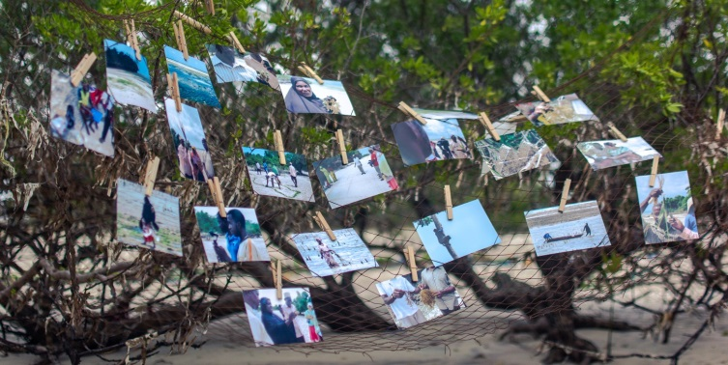
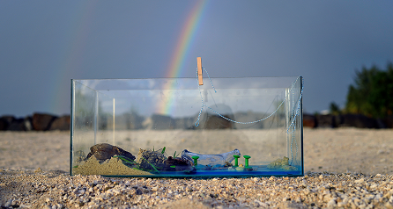
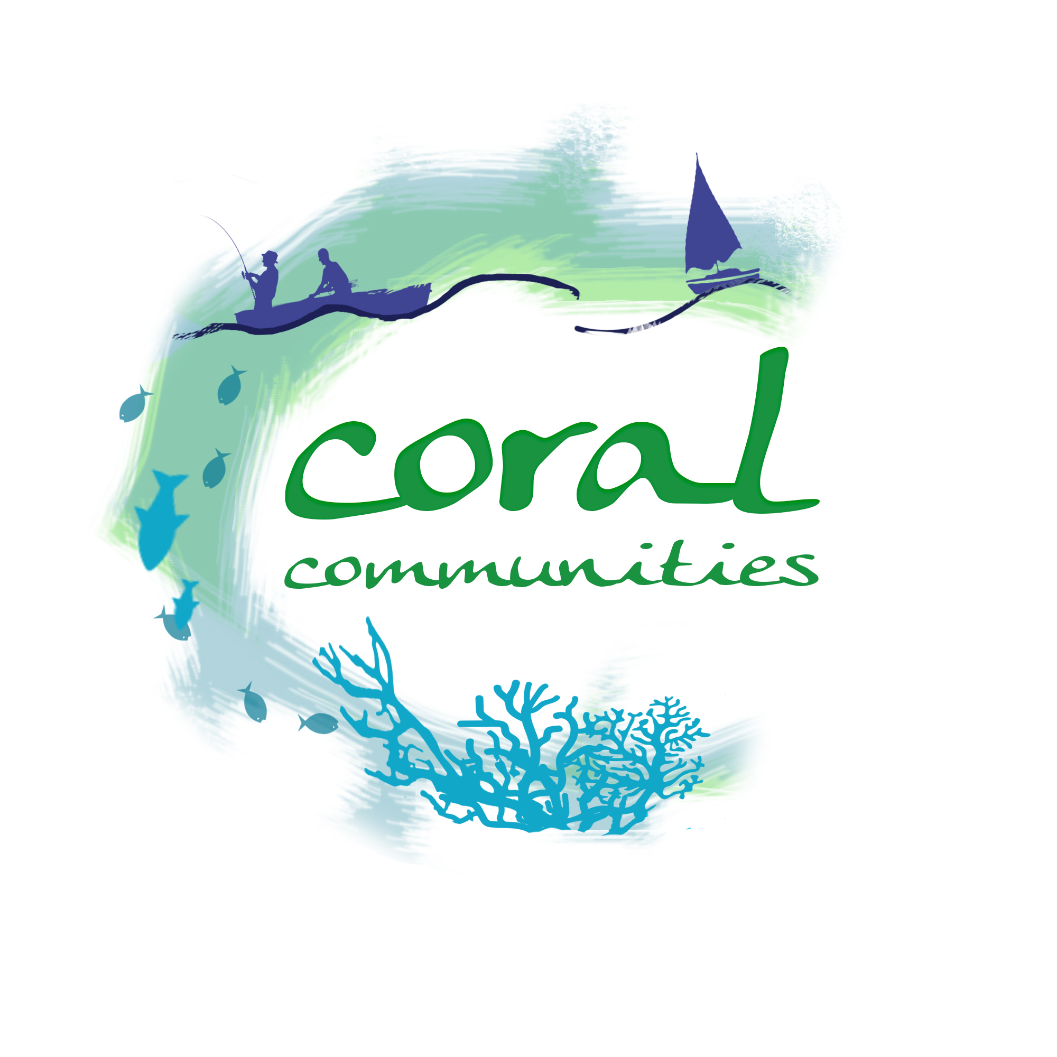
Coral Communities:
© Timur Jack-Kadioglu
© Timur Jack-Kadioglu
© Andy Hughes

Building Resilience of Coral Reefs and Coastal Communities

Exeter Workshop Report

Background
Coral Communities is a 9 month Global Challenges Research Fund (GCRF) project that aims to draw together a network of collaborators from the UK and Western Indian Ocean (WIO) to address evidence gaps and support the development of resilience strategies across the WIO. Coral Communities comprises an interdisciplinary partnership between academics, NGOs, a development consultant and a creative art and film-making team. The Exeter workshop (UK) was a key deliverable for the project, drawing upon outputs from an earlier workshop in Mauritius, a literature review and the piloting of visual methods that aim to support stakeholder and community engagement and co-production.

The Exeter workshop had the following key aims:
- Share and receive feedback on the work that Coral Communities has undertaken assessing resilience strategies in the WIO, and strengthen this assessment with international examples of best practice.
- Brainstorm the potential of ecosystem services approaches to enhance marine management in the UK and internationally, in particular the improved implementation of strategies to build social and ecological resilience.
- Showcase novel visual methods trialled with communities in Mauritius and Zanzibar, let participants try out this method, and gather examples and experiences of where visual methods are being used effectively elsewhere.
Workshop sessions were developed around each of these aims.

1. What is resilience?
Based on discussions with stakeholders from the WIO and evidence from the literature review undertaken as part of Coral Communities, resilience was presented as the ability to resist, recover, adapt and bounce back from any kind of pressure, but not necessarily to the same state. It was noted by WIO stakeholders that the word resilience is rarely employed in outreach activities where terms such as sustainability, durability and adaptation were more commonly used (see presentation slides for more detail).
Key issues raised during the Exeter workshop included:
- In a policy context, resilience goes beyond the environment. It is considered a developing concept and policy-makers are asking how useful is it, what can it do, how do you measure and implement it? What becomes of the concept remains to be seen.
- There is an important economic angle to resilience. For example the economies of many Small Island Developing States (SIDS) depend on the marine environment. By mapping and valuing the ecosystem, the economic argument for environmental protection can be demonstrated and so increase buy-in from coastal communities, especially in terms of reefs as protectors from damage.
- Resilience can be approached from different angles. For example, one of Blue Marine Foundation’s projects in the Maldives is looking at top-down ecological effects (i.e. the state of grouper predators) as well as the state of the reef in attempt to improve the grouper fishery. Elsewhere coral and mangrove restoration are seen to have multiple benefits for the wider ecosystem.
- There are many concepts in use that overlap and have more or less the same meaning. For example, projects focusing on reef function and the role of different species have some resilience framing, but so have ecosystem-based management and integrated coastal zone management.
- Concepts and terminology may be set in policy approaches, which may be hard to change. New concepts, such as resilience can be used to tweak existing policies towards new goals, but there is a need to define what these new concepts are striving for.
- The ability to make decisions (e.g. by local people about local issues) is important for resilience in the long-term. Community buy-in is needed and this needs to be built upon community understanding and empowerment.
- Adaptive capacity is important, more so than the actual adaptation, as this allows people to respond to any threat in their own terms.
- Faith based approaches, co-management and socially acceptable scalable approaches are more widely complied with as they align with to local values and priorities.

2. Ecosystem services and resilience
Participants were divided into three groups and asked to explore the links between ecosystem services (ES) and resilience.

2.1 Experiences of ES, when the concept is useful and for who?
Participants had a variety of experiences with ecosystem services, from academic, business, policy and community perspectives. While concern was raised that the term can be very academic and challenging to understand, a key conclusion was that the context is important, as is the audience, and that determines how the concept is used:
Academic: considered a useful way to ensure that research is relevant.
Business: the language of ES and monetary value is extremely useful for businesses. If you can explain why someone should do something (e.g. to protect themselves) and that it will affect them financially, then it is an easy way to change behaviour and incentivise responsible use of ecosystems.
Community: the ES concept can support people without an academic background to understand the importance of the environment and the benefits it provides. Communities are happy to talk about the value of the environment, but not necessarily using ES terminology. The concept can help communities to think about the relationships between livelihoods and management, the implementation of planning and to identify issues and aspects related to community livelihoods.
Faith based organisations: not using the concept as such, but are encouraging people to look at their environment in a different way.
NGOs: do not necessarily work with the concept itself in practical terms, but do use the logic of ES in trying to convince partners to look beyond specific resources and to consider the broader ecosystem (i.e. for system-level and integrated approaches).
Policy: there is considerable experience of ES in policy. It has encouraged broader thinking and has been useful for creating awareness of the value of nature and how to sell this to sectors beyond the biodiversity sector. It can be important when trying to convince policy-makers to invest in certain areas, especially when budgets are limited and demands are multiple. In this sense ES is largely equated to monetary value.

2.2 Is concept applicable in practice?
Many examples were given where the ES concept is being used in practice. For example:
Oyster restoration: supports a number of ES including provisioning services for fishers, water purification and general improvements to ecosystem productivity. An emphasis on ES has convinced funders and users about the importance of preserving oysters. The approach is well established in the US and is being brought to the UK (by Blue Marine Foundation).
Green infrastructure in Florida: hurricane Sandy was estimated to have resulted in damage worth US$60bn. Work was undertaken to value of the wetlands and their role in loss reduction. They were estimated to have reduced losses by US$625mn, supporting the argument for their retention and restoration. Construction companies are now working on integrating green infrastructure with grey to increase resilience (e.g. growing mangroves around bridges). These actions are reflected in the lending that is available to businesses, the cost of finding finance, insurance premiums and the banking rates that they can access.
Green infrastructure in the UK: following flooding in the UK, effort is being channelled into re-bending rivers, looking at the value of flood plains and re-establishing green infrastructure.
Blue carbon projects: Blue Ventures is working with communities in Madagascar to support mangrove management via blue carbon trading.
Dynamite fishing in Tanzania: Mwambao is using the idea of ES to help people and government understand that dynamite fishing doesn’t only blow up fish, but also the reef, which affects the coasts, fisheries and livelihoods.
Insurance products for coral reefs: Willis Towers Watson is looking at how they can develop an insurance product for coral reefs. This involves trying to understand what makes reefs resilient, what functions we want reefs to have, and how they can incentivise responsible use of reef ES (e.g. to incentivise hotels not to discharge sewage on to reefs, what to do if a cruise ship damages the reef and how to rebuild it, paying fishers not to fish). It was noted that the protective role of reefs might be limited in high-energy events. The bigger issue is sea-level rise, as reefs won’t be able to keep up with it. The location of many hotels may by unsustainable in 30-40 years due to erosion and beach loss.
Resilience bonds (green and blue): these are being developed to support environmental improvement to mitigate future events. They are longer-term investments that don’t repeatedly pay out small amounts, but pay out larger amounts to reduce future risk. They are new, and their benefits are not yet known.
A number of challenges in the use of ES concepts were also highlighted:
- Budget constraints: in Tanzania, until monetary values can be put on reefs and the cost of dynamite fishing, the government is not going to be convinced to invest because there are already so many other demands (e.g. police, magistrates, education). The situation is similar in Mauritius where the monetary values of ecosystems and the impact of management activities are needed to convince the government to invest.
- Different people have different needs: people have different reasons why reefs are needed and it may be difficult to balance these needs. A benefit for one may be a dis-benefit for another.
- Ownership and empowerment: until people feel some local ownership they may not take responsibility for an area. Governments also need to give responsibility to local governments/communities where appropriate.
- Population: there are more and more people needing more and more resources, and with limited employment opportunities in some locations, people turn to the sea.
- Criminality: illegal activities can undermine even the strongest regulations and laws.
- Context: what works in one location may not work in another e.g. the community development fund developed with Mwambao in Zanzibar may not work as a model in Mauritius where needs, wants and culture are distinct.
- Terminology: flexibility and malleability in terminology is important as is using terms that are relevant to people, more so than correct terminology (e.g. environmental resilience vs. climate change; voluntary marine no-take areas vs. voluntary marine conservation areas or fish breeding areas).
- Adaptation vs. maintenance: are we fixated on maintaining when we should be focusing on adapting?
- Timeframes: there is a need to support people through periods of transition e.g. if benefits from an action are not going to accrue for five years, what can be done to support people during this five year period. This is the problem of long-term solutions as first solutions. There needs to be a package of short- and long-term activities.
- Compensation: regionally and globally, the benefits of conservation outweigh the costs, but local communities often pay the costs of conservation activities. What mechanisms can be put in place to compensate them?
- Shifting baselines: what we value now may be completely different to what someone valued 20 years ago or what may be valued in 20 years’ time (e.g. a pristine reef 20 years ago vs what people see today).
- Trend to monetisation: economy and jobs dominate policy, and monetary value speaks to this audience, but there may be opportunities to broaden the approach e.g. through concepts of health and well-being and to better include qualified information.
- Linking catchment to coast: land activities influence the sea, can the ES concept help join up management activities?
- Project scale: the European Investment Bank is looking to bring in private investment to nature conservation, but projects are currently not of sufficiently large scale to meet the needs of the bank.
- Action: depends upon many things including the receptiveness of government and their agencies to resilience and resilience building strategies, funding and exit strategies, legacy reporting and lessons learnt.

2.3 In practice, does ES approach capture the wider/diverse values for the environment?
There were some contradictory thoughts about the extent to which ES capture the different values for the environment. For example:
- Ecosystem services are often equated with monetary value, meaning that cultural services are not well captured.
- We are naturally led to think about what resources do for us and their economic value. ES is useful for broadening out to cultural services.
The importance of non-economic values was raised alongside concern over the ES concept. ES assumes the environment is a service for humans, but some participants considered that this relationship is symbiotic. The ES approach does not capture faith values which emphasis the human connection with the environment, not just what can be taken from it. At the community-level other concepts may be more meaningful than ES such as ethics and custom. However, as you move to higher levels of governance these alternative framings may be limited. For instance, at government levels, even in religious countries, government departments become more secular, hence appeals to religious ethics become less powerful (even devoted individuals are constrained by competing governmental priorities). At these other levels ES or similar concepts may be more practical. It may therefore be useful to use ES alongside other meaningful ideas and concepts across scales.
It was suggested that if communities want to use other values (e.g. faith values), then this could be capitalised upon (e.g. through faith leaders). For example, in Indonesia, Imams are part of Fatwas on deforestation and biodiversity. These are a very powerful group of Imams with considerable religious authority, but not political power. They work at the local level and influence local politicians who can transfer the message. The process of politicisation is not easy and politicians themselves need to be sensitised.
The importance of health and well-being as alternative framing was also raised. It was felt that health and well-being are slowly entering into debates about the environment, but this angle is still limited in platforms such as the UN Ocean conference.

2.4 Can ES support resilience? Does this differ when considering: long-term vs. short-term strategies or local vs. global causes of environmental change?
ES and resilience were discussed as concepts that can be supportive of each other. The ES framework can be considered as an extra step on the social-ecological resilience spectrum, linking strategies together (e.g. human/population health and microfinance) by linking community and ecology. The ES framework may also help the capture of wider issues such as culture and education, which might not be considered when just thinking about resilience.
Participants suggested that the ES approach could help highlight the benefits of particular management activities that may be introduced to build resilience. For example, MPAs can be considered a threat to livelihoods, but ES concepts can help to flag up the potential benefits to communities. The ES concept may also support understanding of the impacts of external stressors (e.g. climate change) on resilience strategies, both in the short and long-term.
It was suggested that the ES concept pushes us to think in the longer-term, especially in relation to regulating services. Using ecosystems to protect us from harm is about resilience and resilience compatible activities. It forces us to think about trade-offs and synergies and to think holistically (at least at a conceptual level).
Other links between the ES concept and resilience at different levels and scales were also highlighted:
- SDGs: The ocean has its own Sustainable Development Goal (SDG), but contributes to many others. The ocean is becoming less siloed with a more integrated policy narrative and the ES approach can support governments to think more about what sustainable growth and the blue economy may mean.
- Wider stakeholder engagement: ES can engage with a wider range of stakeholders who may then develop a stake (e.g. businesses through Payments for Ecosystem Services (PES) schemes).
- Dealing with global scale threats: The ES concept might be useful at the government or industry level by supporting them to deal with wider threats e.g. climate change, international trawling. Resilience can be built to these global threats by minimising local impacts and there are some great local level models that can benefit from ES thinking.
Alternatives to the ES-resilience link were also identified. For example, resilience translated into risk, insurance and costs was considered a good way of framing it, rather than using language and concept that people don’t really understand (i.e. ES). The idea of risk, risk sharing and paying into the insurance model is more familiar.

2.4.3 Examples of where ES thinking can support resilience
Despite concerns that ES is often equated with monetisation, participants tended to connect ES thinking and resilience outcomes through financial products. This may reflect the experiences of the participants, but also an established policy focus and/or an opportunity for new and creative ways to connect ES and resilience.
Financial products | Examples
Catastrophe risk insurance facility | Sovereign products structured around typhoon damage, drought and excess rainfall. To receive payment of disaster funds, countries need to have demonstrated adherence to a set of guidelines about how funds will be distributed (e.g. environmental codes).
Microfinance and insurance | Bags of seeds are sold with SIM cards. Once the SIM is registered, the farmer is covered by an insurance product. If there is a drought and crops die, the farmer is paid a premium to help him/her buy more seed.
Community conservation funds | Mwambao is piloting a community fund in Zanzibar where individuals or communities can be eligible for a lump sum if they adhere to the management plan and by-laws.
PES schemes in Guatemala, El Salvador and Honduras | Water catchment PES schemes have been developed to support farmers upstream to improve their own yields and halt particular activities for downstream benefit. Not introduced to build resilience per se, but thinking about climate change and risk reduction.
Green taxes | In the Maldives for example, all tourists pay a tax that goes towards a government fund focused on waste management
Other financial products | Using access to additional funds and reduced lending rates as a mechanism to encourage green behaviours (e.g. use of porous building materials to reduce run-off).

3. Visual activities
The afternoon session comprised two parts: presentations on visual methods and the preparation of coastscapes. The following highlights the key points from these sessions.

3.1 What is the purpose of visual activities?
- The method is a research assemblage bringing together not just a researcher and a participant but rather a landscape setting (it becomes like a stage for discussion).
- The methods can assist participants/communities to look after, learn and data-base their patch (they are co-producers).
- As the method is visual, it overcomes issues of literacy, but care is needed as visual imagery can mean one thing to one participant/community and something else to a different community in a different setting. It is therefore important that participants shape their own visuals ensuring that their voices are heard.
Picture by J. Parsons

3.1.1 How was this approached in Coral Communities:
- Participants were supported to create their own coastcapes using representation, simulation or abstraction.
- Perceptual data about the landscape was elicited whilst in the landscape with people.
- Visual, text based and participatory video (PV) approaches were applied to the process.
- The film making team as well as the community were involved in this process.

3.1.2 Key lessons learnt from application in Mauritius and Zanzibar
- Clarity in instructions: the reason why community members are being asked to do things (e.g. bring objects from home, collecting water) needs to be clearly explained to avoid activities becoming too abstract.
- Benefits of group working: participants enjoyed working together to make the landscapes and filming each other.
- Clarity in communication: participants felt it was important to use practical language especially when dealing with concepts such as resilience and livelihoods.
- The power of sharing: participants were very eager to share their natural places and why these places are important to them.
- An opportunity for bonding between participants: it can be useful in bringing different communities together and share experiences.
- Pushing the boundaries: feedback from the communities revealed that the interviews that accompanied the visual activities were enjoyable, interviewees felt part of the process and that their point of view was important but some found the ‘feeling-based’ questions tricky.

3.1.3 Next steps
- Encourage others to have a go (and let us know if you do): the activities are open, enduring and sensory and can be easily replicated.
- Incorporate into a Geographical Information System (GIS), such as QGIS an open source GIS software: it was discussed and explained how (Q)GIS could become part of the process.

3.2 Tools and resources
Coral Communities will be producing two key outputs focusing on visual methods:
- A short ‘how to’ film illustrating the main elements of the visual method (link to come).
- A newspaper aimed at communities and NGOs, providing more information about visual methods that can be an accompaniment to the ‘how to’ film as well as a stand-alone document.
Project partner, Mwambao Coastal Community Network, also produced a short film about the activities carried out in Fundo Island, Zanzibar (https://vimeo.com/238758875)
Mwambao Coastal Community Network regularly uses participatory video as a community engagement tool. A short film explaining their approach can be found here: ‘Participatory Video for Documentation and Lesson Sharing in Fisheries Management’ https://www.youtube.com/watch?v=T9wLZrXGhGc

3.3 Practical visual activities
Stage 1: sharing of objects based on the workshop brief: ‘Bring an item to the workshop on Thursday that means something to you about the coast and that you can talk about in terms of ecosystem services. This can be an object or an image (e.g. a photograph or a picture from a newspaper/magazine), or anything else that springs to mind.’

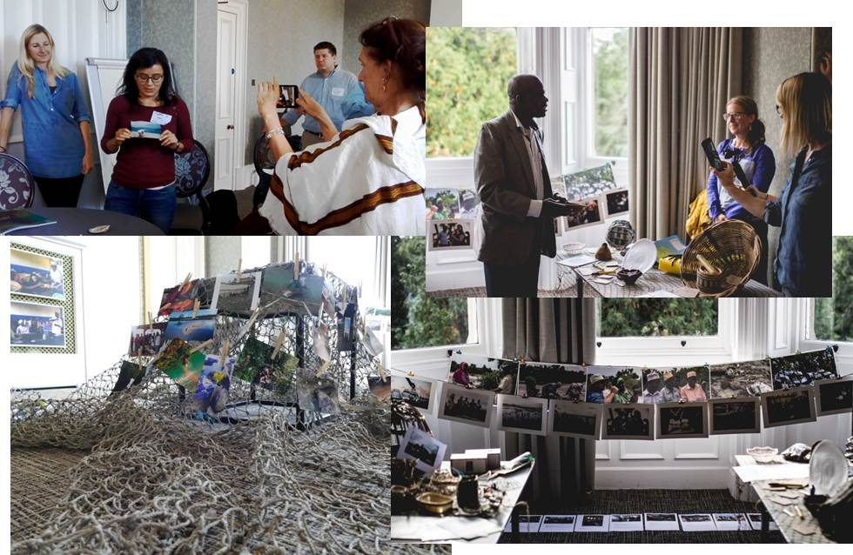Pictures: J. Parsons; (TR and BR) K. Boot (BL); C. Hattam (TL).

A short video of the sharing exercise can be found here: https://www.youtube.com/watch?v=nPOuSzNIxTE&feature=youtu.be
Stage 2: creation of coastscapes participants were invited to identify, discuss and create a representation of a coastal ecosystem. Coral Communities project team members began filming and encouraged participants to film each other.

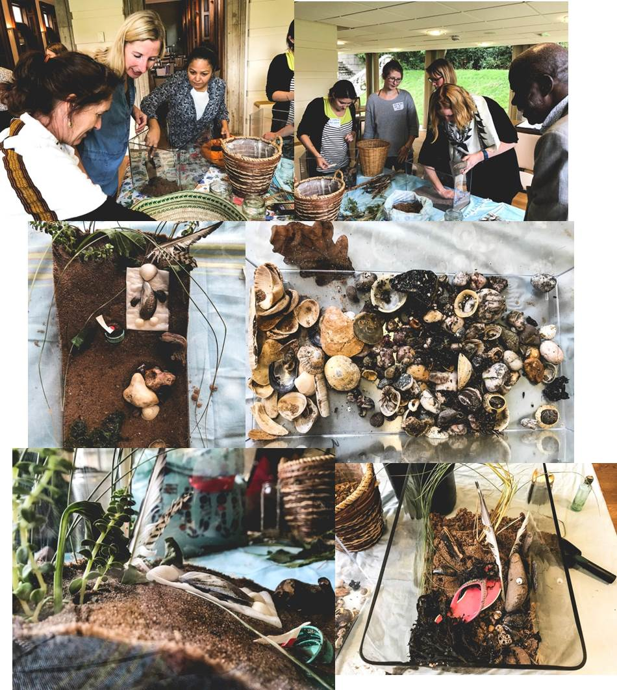
Pictures: J. Parsons

4. Closing thoughts
The process of using visual methods is rich because:
- Past as well as present practices can come to light e.g. historical ways in which resources were managed.
- Very deep local knowledge can come out quite quickly as can hard to reach emotional knowledge.
- Fosters informal dialogue by bringing communities and policy makers around a shared exercise (e.g. tank in which they build a coastscape).
- It could be digitised if time, and more funding, were available and so presented in different ways to policy as well as to community and other stakeholders.
- The video, photographs and the making are about perspective taking, but also understanding each other’s perspectives and building empathy.
- It is a great forum for bringing communities into the conversation and engaging with new stakeholders.
- It builds a lot of trust. If you are going to continue to work in a community and you have carried out these kinds of exercises with them, they start to know you as a person.
- It is a skill that regardless of education level everyone can engage with and builds capacity and confidence.
- Time is needed to do this, and this can be especially important when meeting communities for the first time.

Annex 1: Workshop Participants

Name | Organisation
Abigail Leadbeater | Blue Ventures
Ali Thani | Mwambao Coastal Community Network
Andy Huges | Freelance photographer and lecturer in photography, Truro College
Caroline Hattam | PML
Chris Perry | School of Geography, University of Exeter
Dan Fairweather | Willis Towers Watson
Dominica Williamson | Freelance artist and designer
Fazlun Khalid | IFEES (Islamic Foundation for Ecology and Environmental Sciences)
Jason Parsons | Photography student (Plymouth University, formerly Truro College)
Karyn Morrissey | European Centre for Environment and Human Health, University of Exeter Medical School
Kathy Young | Reef Conservation, Mauritius
Katie Hart | Global Challenges Research Fund (GCRF)
Kelvin Boot | PML
Lorna Slade | Mwambao Coastal Community Network
Louisa Evans | Environment and Sustainability Instutute, University of Exeter
Marianne Kettunen | IEEP (Institute for European Environmental Policy)
Mark Bryant | IFEES (Islamic Foundation for Ecology and Environmental Sciences)
Megan Hunt | Willis Towers Watson
Nicola Frost | Flora Fauna International
Olivia Rendon | PML
Sian de Bell | University of York
Simon Harding | Blue Marine Foundation
Tara Hooper | PML
Tom Hooper | Travel Foundation

